**GOLDEN ELITE EXAMINTIONS 2020**

**231/2**

**BIOLOGY**

**PAPER 2**

**MARKING SCHEME**

1. (a)
2. Protandry: condition in which stamen/anthers of a flower mature before the carpels/pistils/stigma;***(1 mark)***
3. Self sterility; pollen grains from anthers of a flower fail to germinate on the stigma of the same flower ; ***(1 mark)***

(b) (i) Q- Antipodal cells/embryo sac wall;

R - Polar nucleus/nuclei;

S - Egg call/ovum ***3 marks***

1. Secrete enzymes that digest the stigma/style/ovary tissue;

Offer passage for male nuclei to the ovum; ***2 marks***

(c) Award if correctly shown in the diagram; ***1 mark***

2. (a) Excess amino acids are deaminated/amino group is removed/amino group is converted in to ammonia; ammonia combines with carbon(iv) oxide(in the ornithine cycle) to form urea; carbohydrate group is converted into glucose for respiration/glycogen for storage;

2NH3+CO →CO (NH3)2 +H2O ***3 marks***

(b) Glomerulus; Bowman’s capsule; proximal convoluted tubule; distal convoluted tubule; 3 ***marks***

(c) (i) Production of large amounts of dilute urine/diuresis; ***1mark***

(ii) Diabetes inspidus; ***1mark***

3. (a) (i) Using a living organism to regulate/control/reduce/check the population of another organism;

***1mark***

1. Catscontrolling mice; beetles controlling water hyacinth; fish in ponds controlling mosquito larvae;

Majimoto ants controlling scales; goats controlling weeds in plantations; ***any 1 (1mark)***

(b) (i) eutrophication is enrichment of water bodies with nitrates/phosphates/ammonium ions/sulphates/nutrients; due to discharge of sewage/domestic effluents/kitchen wastes containing detergents/run off water containing fertilizers; leading to rapid growth of surface plants/algae bloom/aquatic plants/phyloplanktons;

*Acc symbols for ions (aq) must be present.*

*Rej kitchen wastes alone*

*Reg domestic wastes* ***3 marks***

1. (Proliferation of plants) block light from reaching plants underneath which will not photosynthesise; the plant die and decompose leading to depletion of oxygen/lack of oxygen ;( as a result) animals also die/suffocate (to death); Reg *organisms die* ***3 marks***

**(c)** Nitrogen (IV) oxide; sulphur (IV) oxide;

*Acc Nitrogen Dioxide and sulphur dioxide*

*Reg oxides of sulphur and nitrogen*

4. (a) - Broad and flat to absorb maximum light;

- Have chloroplasts which contain chlorophyll for trapping light;

- Transparent cuticle to allow light to pass through;

- Palisade cells are near the upper surface for optimum absorption of light; ***2 marks***

(b) X - Carbon (IV) oxide;

Y – Oxygen;

(c) (i) Xylem;

(ii) Phloem;

(d) Starch is insoluble in water; hence osmotically inactive; this reduces the effect on absorption of water

5. (a) Iodine solution was poured on the agar; ***1 mark***

(b) Millet seeds produced amylase; that converts starch to maltose***2 marks***

(c) To activate the enzymes; ***1 mark***

(d) To increase surface area for exposure of enzymes; ***1 mark***

(e) Starch would not be digested since the enzymes would be denatured by boiling;

(f) Placing millet seeds that have not been soaked; in water on the agar/boiled millet seeds on the agar;

***2 marks***

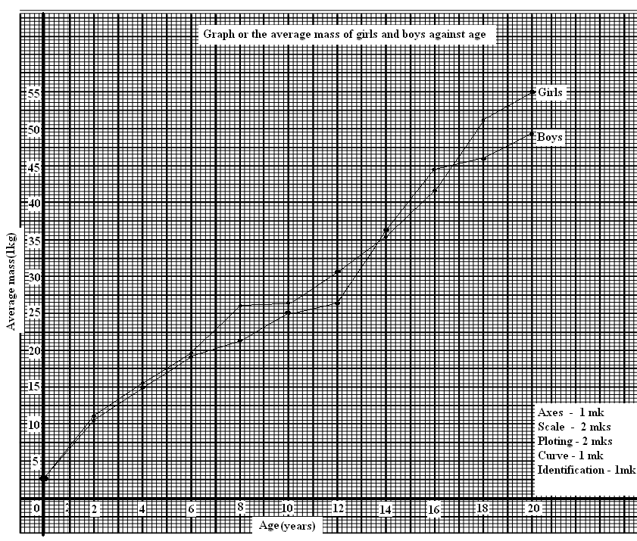6. (a)

(b) (i) 26 kgs± 0.5;

(ii) Girls 15 yrs - 39

Girls 13 yrs - 33

6

6 ÷ 2; = 3.0 kg/year;

(c) Girls at adolescence grow faster; there is an increase in the size of hips and breasts;

(d) Girls generally grow faster than boys /boys grow slowly compared to girls; but later after puberty they grow more steadily.

(e) Girls above ten years begin the menstruation cycle; they need more iron to replace the blood lost during menstruation;

(f) Height of the body; volume of the body;

7. **Mouth;**

* + With teeth for chewing to increase the surface area for digestion and easy swallowing
  + Has salivary gland which secrete saliva to soften and lubricate food for easy swallowing
* Has muscular tongue to turn food sideways for proper mixing with saliva and chewing
* Rolls food in to boluses and pushes them down the gullet
* Saliva has saliva amylase to initiate digestion of starch;

**Oesophagus**;

* Has circular and longitudinal muscles to propel food in to the stomach by peristalsis

**Stomach;**

* Has cardiac sphincter muscles to allow/regulate food into the stomach
* Pyloric sphincter to retain food for digestion in the stomach
* With gastric glands that secrete mucus to protect wall of the stomach from digestive enzymes; enzymes pepsin and rennin to digest proteins;hydrochloric acid to kill bacteria in food;and provide optmum PH for protein digestion,activation of pepsnogen
* With muscular walls whose contaction churn/mix chyne with digestive enzymes.

**Duodenum**

* With brunners glands in its walls to produce alkaline fluid and mucus
* Has crypts of lieberkuhnwhose cells produce digestive enzymes
* Is connected to the pancrease and the liver which supply pancreatic juice and bile respectively
* Bile emulsifies fats and neutralizes the acid from the stomach. Pancreatic juice contains digestive enzymes/pancreatic lipase, pancreatic amylase and Trypsin that acts on lipids, starch/amylase and proteins respectively.

**Ileum**

* Long to allow complete digestion and absorption of food
* With villi and microvilli to increase surface area for digestion and absorption
* Folded to increase surface area for digestion and absorption
* Narrow to keep digested food in contact with epithelium to reduce distance over which food diffuses
* With moist inner surface to enhance absorption of nutrients
* With epithelical cells continuously replaced
* Has lacteals for fat transportation
* Has muscular walls for peristaltic movement of food

**Colon**

* Folded to increase surface area for absorption of water and mineral salts
* With muscular walls for peristaltic movement of undigested food

**Rectum**;

* Secretes large amounts of mucus for lubrication to aid defecation

**Anus**

* With muscular sphincter to control defecation

8. Causes of air pollution

* Sulphur and nitrogen dioxide ;; from industries
* Carbon (iv) oxide ( from combustion of fuels in industries and motor vehicles);
* Dust and smoke (from quarries and factories)
* Radio active radiations(from atomic and nuclear plants)
* Agricultural chemicals used as sprays;
* Noise from factories and vehicles; ***mark any five***

***Effects on organisms***

* Sulphur dioxide/nitrogen dioxide/dust/smoke/carbon iv oxide and agricultural sprays cause respiratory diseases; and irritate respiratory systems;
* Nitrogen dioxide /sulphur dioxide combine with atmospheric moisture to form acidic rainfall which is corrosive; poisonsplants; lower metabolic activities/photosynthesis; acidic soils destroy vegetation.
* Dust/ smoke reduce amount of light reaching on the plant lowering photosynthesis;
* Carbon II oxide is a respiratory poison/combine with haemoglobin reducing oxygen carrying capacity of red blood cells;
* Carbon iv oxide causes green house effect by forming a layer around the earth’s atmosphere/insulate the earth causing global warming/ change of climatic patterns;
* Radioactive radiation causes mutation and cancer;

**Control methods**

* Erect factories and power generating station from residential areas;
* Build factories with chimneys to discharge waste gases up the ground;
* Educate people on dangers of air pollution;
* Filtration of waste gases to remove poisonous pollutants before being discharged into the air;
* Use of alternative less polluting fuels like hydroelectric power/lead free fuels;
* Use smokeless fuels in houses and factories;
* Banning manufacture and use of chemical weapons;
* Impose heavy fines on air pollutors; (like factories)